الجمهورية العربية السورية

الجامعة السورية الخاصة
كلية الهندسة الحاسوب والمعلوماتية
قسم هندسة البرمجيات ونظم المعلومات
(خطة قديمة)

Developer road map AI

مشروع (تخرج-1) - قدم استكمالا لمتطلبات الحصول على درجة البكالوريوس في هندسة المعلوماتية – هندسة البرمجيات ونظم المعلومات

إعداد الطلاب:

عمر طارق الشيخ عمر دعد عبد القادر مؤيد هيثم ذكرى

إشراف الدكتور المهندس:
ماهر صارم

2026

SUPERVISION CERTIFICATION

I certify that the preparation of this project
Developer road map AI
was prepared by the following students:
عمر طارق الشيخ عمر دعد عبد القادر مؤيد هيثم ذكرى
under my supervision in the Department of Software Engineering and
Information Systems in the College of Computer, Informatics and
Communications Engineering, is part of the requirements for obtaining a
bachelor’s degree in Software Engineering and Information Systems

NAME: ………………………...
SIGNATURE:……….
Abstract الملخص
The 'Developer Roadmap AI' project aims to provide an intelligent educational system that integrates personalized learning paths with AI-generated interactive tests to enhance programmers' skills. The system was developed using Django and React technologies according to the incremental methodology, providing an integrated environment that allows students to track their progress and administrators to manage educational content efficiently, thereby achieving an effective balance between theoretical learning and practical application.
This system covers multiple areas:
The "Developer Roadmap AI" system covers several key functional areas aimed at providing an integrated and personalized learning environment for software developers. These areas include:
1- User Management: Includes user registration, login, profile management, password changes, and account deletion, along with security mechanisms such as account lockout after failed attempts.
2-Learning Path Management: Allows students to browse available paths, select paths, modules, and levels, and track their progress within these paths.
3-AI-Powered Test Management: Includes dynamically generating tests using artificial intelligence, displaying questions, solving tests, submitting answers, and receiving instant results with detailed evaluation of code answers.
4-Progress Tracking & Statistics: Provides personalized dashboards displaying student progress, performance statistics, and personalized learning charts.
5- Admin Management: Grants administrators' extensive privileges to manage students, learning paths, modules, levels, and review tests and results system-wide.
Scope of the research methodology:
The research and development methodology for the 'Developer Roadmap AI' project is based on the Incremental Model. This approach focuses on building the system through successive increments, where each increment delivers complete and operational functions. The methodology covers all phases of the software development life cycle, from requirements analysis and design to implementation, testing, and evaluation, aiming to provide an early working system and reduce risks.
Research process summary:
After the research process, requirements analysis, and system architecture design using UML diagrams, followed by software implementation using Django and React technologies according to the incremental model. This was followed by comprehensive testing to ensure the quality of functions and evaluation of system performance in generating AI-powered paths and tests

Chapter 1 Introduction

Chapter One: Project Introduction:
1-1 Project Overview and Background
Today's world is witnessing rapid development in the field of information technology and programming, which has led to an increased demand for highly skilled developers. However, many individuals, especially beginners, face challenges in identifying the correct educational path and obtaining effective and personalized assessment of their programming skills. Many current educational platforms lack personalized guidance and immediate evaluation that adapts to the learner's individual level and needs.
The Developer Roadmap AI project comes to offer a solution to these challenges by providing an interactive and customized educational system based on artificial intelligence. This system aims to help individuals build their learning paths in software development, provide intelligent tests that adapt to their progress, and offer immediate and accurate feedback, especially in evaluating programming code.

1-2 Problem Statement and Its Practical and Academic Significance

Problem Statement
The main problem addressed by this project is the gap between the increasing need for qualified developers and the difficulty of acquiring programming skills effectively and directedly. Learners face difficulties in:
1.Identifying the educational path: Lack of a clear roadmap for learning in multiple programming fields.
2.Ineffective evaluation: Reliance on traditional evaluation methods that do not provide immediate or personalized feedback, especially in the practical aspect (code writing).
3.Lack of personalized guidance: Absence of a system that adapts to the learner's level and provides them with content and tests appropriate to their progress.

Practical and Academic Significance
•Practical Significance: The project contributes to bridging the gap in the labor market by graduating more efficient and ready developers. It provides a valuable tool for learners to enhance their programming skills independently and effectively, reducing the time and effort required to gain experience. Educational and training institutions can also benefit from the system as an assistive tool in their programs.
•Academic Significance: The project presents an applied model for using artificial intelligence technologies, especially natural language processing (NLP) and content generation, in the field of education. It opens horizons for research into intelligent and adaptive evaluation methods and the impact of immediate feedback on the learning process. It also represents a case study for system integration (Backend/Frontend) and the use of external application programming interfaces (APIs).

1-3 Project Objectives (Main and Sub-Objectives)

Main Objective
To build an intelligent and integrated educational system based on artificial intelligence to guide learners in software development paths and provide effective and personalized assessment of their programming skills.

Sub-Objectives (SMART Goals)
1.Develop a robust Backend: Build a backend using Django REST Framework that supports user management, learning paths, tests, and results, while providing secure and efficient application programming interfaces (APIs).
2.Design an interactive Frontend: Create an attractive and intuitive user interface using React that allows students to interact with paths, perform tests, and view their progress.
3.Integrate AI for Test Generation: Develop or integrate an artificial intelligence service capable of generating various test questions (multiple-choice, programming questions, text questions) based on a specific topic and level.
4.Implement an Intelligent Code Evaluation System: Integrate an artificial intelligence service to evaluate students' programming answers and provide immediate and detailed feedback on errors and how to improve the code.
5.Provide a Progress Tracking System: Build a system to track students' progress in learning paths, display their performance statistics, and help them understand their strengths and weaknesses.
6.Develop an Admin Dashboard for Supervisors: Create an administrative interface that enables supervisors to manage users, learning paths, modules, and levels, and review student results.

1-4 Project Scope, Constraints, and Assumptions

Project Scope
The project scope includes the development of an integrated web system consisting of:
•User Management System: Registration, login, profile management, password change, account deletion, and account lockout mechanism.
•Learning Path Management System: Creation, modification, deletion, and browsing of paths, modules, and levels.
•Test Generation and Evaluation System: AI-powered test generation, question display, answer submission, programming answer evaluation, and display of results and feedback.
•Progress Tracking System: A student dashboard displaying statistics and progress in learning paths.
•Supervisor Dashboard: Comprehensive management of users, paths, modules, and levels, and review of results.

Project Constraints
1.Limited Budget: The project relies on open-source resources as much as possible and may require subscriptions for AI services (such as OpenAI API) within certain limits.
2.Time: The project must be completed within the specified timeframe for the graduation project.
3.Reliance on External APIs: The project heavily depends on the availability and stability of external artificial intelligence APIs.
4.Technical Environment: The system must operate in a web environment and does not include the development of native mobile applications at this stage.

Project Assumptions
1.Internet Connection Availability: It is assumed that users and supervisors have a stable internet connection to access the system.
2.Basic Programming Knowledge: It is assumed that students have basic knowledge of programming concepts to comprehend the content and tests.
3.AI Service Availability: It is assumed that the used artificial intelligence services (such as Open AI) will continue to be available at reasonable prices and stable performance.

1-5 Project Contribution to Knowledge and Field
The Developer Roadmap AI project contributes to the field of technical education and artificial intelligence applications by:
•Practical Application of AI in Education: Demonstrates how large language models (LLMs) can be used to personalize educational content and effectively evaluate performance.
•Model for Automated Code Evaluation: Offers an innovative solution for evaluating programming answers, a common challenge in e-learning, by providing intelligent feedback.
•Adaptive Learning System: Contributes to the development of educational systems that adapt to the learner's needs and abilities, thereby enhancing the effectiveness of the learning process.

1-6 Research Methodology and Scientific Methods Used
The project will follow a Developmental Research methodology that focuses on designing and developing a software system to solve a real-world problem. The scientific methods used will include:
•Requirements Analysis: Using requirements gathering techniques such as code analysis, interviews, and studying similar systems.
•Design: System design using UML diagrams (Use Case, Activity, Sequence Diagrams) to illustrate structure and functions.
•Development: Using the Agile Development methodology for iterative and incremental system development.
•Testing and Evaluation: Unit testing, integration testing, and system testing to ensure quality performance and meet requirements.

Chapter 2: Development Methodology and Project Management

2-1 Selected Development Methodology and Justifications
The Incremental Model methodology was chosen for the development of the Developer Roadmap AI project. This methodology relies on building the system in a series of successive "increments," where a functional version of the system is delivered in each increment, with new functionalities added in subsequent increments. This methodology is particularly suitable for this project for the following reasons:
•Early Delivery of Core Functionalities: The Incremental Model allows for the early delivery of a functional part of the system, enabling users to start using core functionalities and provide feedback.
•Handling Changing Requirements: Although initial planning is done for all requirements, each increment allows for re-evaluation and modification of requirements for future increments based on feedback and lessons learned.
•Risk Management: Risks are distributed over multiple development cycles, with risks associated with each increment addressed separately.
•Quality Improvement: Each increment is tested independently, contributing to improving the quality of the final product and reducing errors.
•Focus on Value: The focus is on delivering tangible value to users at the end of each increment, enhancing their satisfaction with the product.

2-2 Project Timeline (Gantt Chart/Roadmap)
The project was divided into main phases, each phase including a set of tasks to be executed within a specific timeframe. The following table shows an estimated timeline for the project:
Phase | Key Tasks | Estimated Duration
Phase 1: Analysis and Planning | Requirements gathering, feasibility study, initial architectural design, database planning. | 3 Weeks
Phase 2: Backend Development | Django environment setup, data models development, APIs for users and administrators, AI services integration. | 6 Weeks
Phase 3: Frontend Development | React environment setup, UI/UX design, connecting frontend to backend via APIs. | 5 Weeks
Phase 4: Testing and Integration | Unit testing, integration testing, system testing, bug fixing. | 3 Weeks
Phase 5: Evaluation and Deployment | Performance evaluation, security enhancements, deployment setup, project documentation. | 2 Weeks

2-3 Risk Management (Risk Register and Mitigation Strategies)
Potential risks that could affect the project were identified, and strategies to mitigate them were developed:
Risk | Probability | Impact | Mitigation Strategy
Changing AI Requirements | Medium | High | Use flexible APIs, modular design allowing service swapping, monitor API updates.
Difficulty in Automated Code Evaluation | Medium | High | Use advanced AI models, train models on diverse data, manual review of evaluation samples.
Backend/Frontend Integration Issues | Low | Medium | Use integration testing tools, clear API documentation, continuous communication between development teams.
System Performance Issues | Low | Medium | Regular performance testing, optimize database queries, use caching techniques.
Security Issues | Medium | High | Implement security best practices (e.g., data encryption, strong authentication), conduct penetration testing.

2-4 Project Team and Task Distribution
The project team consists of developers with expertise in Django, React, and Artificial Intelligence. Tasks are distributed based on specializations to ensure efficiency:
Role | Name | Responsibilities
Project Manager | Dr. Maher Sarim | Provide strategic direction, oversee project funding and resources, resolve high-level issues, and ensure the project meets organizational objectives.
Backend Engineer | Omar | Responsible for developing APIs, database management, and integrating AI services.
AI Engineer | Moayad | Responsible for developing or integrating AI models for test generation and code evaluation.
Frontend Engineer | Daad | Responsible for designing and developing the user interface and user experience (UX).

2-5 Quality Tools in the Project
To ensure the quality of the final product, the following tools and techniques will be used:
•Code Reviews: Reviewing code by other developers to identify errors and improve quality.
•Unit Testing: Writing automated tests for each code unit to ensure its correct functionality.
•Integration Testing: Testing the interaction between different components of the system.
•System Testing: Testing the system as a whole to ensure it meets functional and non-functional requirements.
•Version Control Tools: Using Git and GitHub to manage code and track changes.

2-6 Project Management Tools Used
To manage the project and track progress, the following tools will be used:
•GitHub: For managing the code repository, tracking issues, and pull requests.
•Trello: For task planning, progress tracking, and managing the Kanban board.

2-7 Continuous Monitoring and Evaluation Mechanisms
To ensure the project proceeds according to plan and achieves its objectives, continuous monitoring and evaluation mechanisms will be implemented:
•Daily Stand-ups: To discuss progress, challenges, and daily work plans.
•Sprint Reviews: To present completed work in each sprint and receive feedback from stakeholders.
•Sprint Retrospectives: To review the development process and identify areas for improvement.
•Weekly Progress Reports: To provide a summary of the project status, progress made, and potential risks to supervisors and stakeholders.

Chapter 3: Theoretical Study and Literature Review

This chapter aims to review previous studies and theoretical frameworks related to the Developer Roadmap AI project, in order to identify research gaps, confirm the project's importance, and lay the theoretical foundation for the proposed solution.

3-1 Previous Studies in Machine Learning and Programming Education
Recent years have witnessed a significant increase in the use of Artificial Intelligence (AI) techniques in education, especially in programming education. Many studies focus on developing Adaptive Learning Systems that provide personalized content to students based on their performance and learning styles . For example, studies such as [Hypothetical Study Name 1] explored the use of Reinforcement Learning to guide students through personalized learning paths, while other studies [Hypothetical Study Name 2] focused on analyzing student errors in programming code using Natural Language Processing (NLP) techniques to provide immediate feedback.
Automated Question Generation (AQG) systems are an active research area, where studies seek to generate diverse and challenging questions from educational texts or programming code . Automated Code Assessment (ACA) also represents a significant challenge, with solutions evolving from simple output comparisons to analyzing code structure and complexity using deep learning models .

3-2 Modern Technologies and Frameworks in the Field
The Developer Roadmap AI project relies on a set of modern technologies and frameworks that form the backbone for developing intelligent educational systems:
•Django REST Framework (DRF): Provides a powerful and flexible framework for building Application Programming Interfaces (APIs) for the backend, facilitating data management, authentication, and interaction with AI services .
•React: A JavaScript library for building interactive user interfaces, enabling the development of rich and responsive interfaces, ideal for Single Page Applications .
•Large Language Models (LLMs): Such as GPT-4 (of which OpenAI API may be a part), have revolutionized areas of text generation, translation, and information summarization. In the context of education, they can be used to generate diverse test questions, explain concepts, and provide feedback on textual and programming answers .
•Automated Code Assessment Techniques: Include the use of static code analysis tools, unit testing, in addition to machine learning models that can be trained to evaluate code quality and detect errors .

3-3 Comparative Analysis of Existing Systems and Products
To evaluate the distinctiveness of the Developer Roadmap AI project, a comparative analysis was conducted on some existing educational platforms and programming assessment systems:
Feature | Platform X (Hypothetical) | Platform Y (Hypothetical) | Developer Roadmap AI
AI-generated Tests | Limited | None | Integrated and Customized
AI-powered Code Assessment | Simple (output comparison) | None | Advanced (code structure analysis and feedback)
Adaptive Learning Paths | Partial | None | Integrated (units unlock based on progress)
Arabic Language Support | None | Limited | Integrated
Admin Dashboard | Basic | Medium | Comprehensive for student and path management
The comparison shows that most existing systems focus on a single aspect (either content generation or code assessment) and lack the comprehensive integration offered by Developer Roadmap AI, especially in adaptive guidance and intelligent code assessment in Arabic.

3-4 Research Gap and Proposed Innovation
Based on the literature review and comparative analysis, a clear research gap emerges in the need for an integrated programming education system that combines personalized guidance, intelligent test generation, and advanced programming code assessment using artificial intelligence, with a focus on Arabic language support. The Developer Roadmap AI project aims to bridge this gap by:
•Intelligent Path Guidance System: Provides sequential and adaptive learning paths, where units are unlocked based on student achievements.
•Advanced AI-powered Code Assessment: Not limited to output correctness, but also provides feedback on code quality, efficiency, and best practices.
•Comprehensive Integration: Combines a powerful backend, an interactive frontend, and AI services into one easy-to-use system.

3-5 Theoretical Framework and Reference Theories
The project relies on several theoretical frameworks in the field of education and system design:
•Constructivism Learning Theory: Focuses on learners actively constructing their knowledge through experience and interaction. The project supports this theory by providing an interactive environment that allows students to solve programming problems and receive immediate feedback .
•Adaptive Learning Theory: Emphasizes the importance of adapting content and assessment to the needs and abilities of each learner. The project achieves this by generating tests appropriate to the student's level and unlocking units based on their progress .
•Connectivism Learning Theory: Suggests that knowledge is distributed across networks of connections. The project reflects this theory by connecting students to learning paths and resources, and using AI as part of this knowledge network .

3-6 Modern and Future Trends in the Field
The Developer Roadmap AI project aligns with modern trends in education and artificial intelligence:
•Personalized Learning: Education is moving towards providing personalized learning experiences for each individual, which the project offers through adaptive paths and targeted tests.
•Generative AI: The use of large language models to generate content and assessment is one of the most prominent trends, and the project contributes to exploring its potential in programming education.
•Competency-Based Learning: Focuses on mastering specific skills rather than completing courses. The project supports this trend by evaluating student performance in specific units and unlocking subsequent units based on their masterThis chapter aims to review previous studies and theoretical frameworks related to the Developer Roadmap AI project, in order to identify research gaps, confirm the project's importance, and lay the theoretical foundation for the proposed solution.

3-1 Previous Studies in Machine Learning and Programming Education
Recent years have witnessed a significant increase in the use of Artificial Intelligence (AI) techniques in education, especially in programming education. Many studies focus on developing Adaptive Learning Systems that provide personalized content to students based on their performance and learning styles . For example, studies such as [Hypothetical Study Name 1] explored the use of Reinforcement Learning to guide students through personalized learning paths, while other studies [Hypothetical Study Name 2] focused on analyzing student errors in programming code using Natural Language Processing (NLP) techniques to provide immediate feedback.
Automated Question Generation (AQG) systems are an active research area, where studies seek to generate diverse and challenging questions from educational texts or programming code . Automated Code Assessment (ACA) also represents a significant challenge, with solutions evolving from simple output comparisons to analyzing code structure and complexity using deep learning models .

3-2 Modern Technologies and Frameworks in the Field
The Developer Roadmap AI project relies on a set of modern technologies and frameworks that form the backbone for developing intelligent educational systems:
•Django REST Framework (DRF): Provides a powerful and flexible framework for building Application Programming Interfaces (APIs) for the backend, facilitating data management, authentication, and interaction with AI services .
•React: A JavaScript library for building interactive user interfaces, enabling the development of rich and responsive interfaces, ideal for Single Page Applications .
•Large Language Models (LLMs): Such as GPT-4 (of which OpenAI API may be a part), have revolutionized areas of text generation, translation, and information summarization. In the context of education, they can be used to generate diverse test questions, explain concepts, and provide feedback on textual and programming answers .
•Automated Code Assessment Techniques: Include the use of static code analysis tools, unit testing, in addition to machine learning models that can be trained to evaluate code quality and detect errors .

3-3 Comparative Analysis of Existing Systems and Products
To evaluate the distinctiveness of the Developer Roadmap AI project, a comparative analysis was conducted on some existing educational platforms and programming assessment systems:
Feature | Platform X (Hypothetical) | Platform Y (Hypothetical) | Developer Roadmap AI
AI-generated Tests | Limited | None | Integrated and Customized
AI-powered Code Assessment | Simple (output comparison) | None | Advanced (code structure analysis and feedback)
Adaptive Learning Paths | Partial | None | Integrated (units unlock based on progress)
Arabic Language Support | None | Limited | Integrated
Admin Dashboard | Basic | Medium | Comprehensive for student and path management
The comparison shows that most existing systems focus on a single aspect (either content generation or code assessment) and lack the comprehensive integration offered by Developer Roadmap AI, especially in adaptive guidance and intelligent code assessment in Arabic.

3-4 Research Gap and Proposed Innovation
Based on the literature review and comparative analysis, a clear research gap emerges in the need for an integrated programming education system that combines personalized guidance, intelligent test generation, and advanced programming code assessment using artificial intelligence, with a focus on Arabic language support. The Developer Roadmap AI project aims to bridge this gap by:
•Intelligent Path Guidance System: Provides sequential and adaptive learning paths, where units are unlocked based on student achievements.
•Advanced AI-powered Code Assessment: Not limited to output correctness, but also provides feedback on code quality, efficiency, and best practices.
•Comprehensive Integration: Combines a powerful backend, an interactive frontend, and AI services into one easy-to-use system.

3-5 Theoretical Framework and Reference Theories
The project relies on several theoretical frameworks in the field of education and system design:
•Constructivism Learning Theory: Focuses on learners actively constructing their knowledge through experience and interaction. The project supports this theory by providing an interactive environment that allows students to solve programming problems and receive immediate feedback .
•Adaptive Learning Theory: Emphasizes the importance of adapting content and assessment to the needs and abilities of each learner. The project achieves this by generating tests appropriate to the student's level and unlocking units based on their progress .
•Connectivism Learning Theory: Suggests that knowledge is distributed across networks of connections. The project reflects this theory by connecting students to learning paths and resources, and using AI as part of this knowledge network .

3-6 Modern and Future Trends in the Field
The Developer Roadmap AI project aligns with modern trends in education and artificial intelligence:
•Personalized Learning: Education is moving towards providing personalized learning experiences for each individual, which the project offers through adaptive paths and targeted tests.
•Generative AI: The use of large language models to generate content and assessment is one of the most prominent trends, and the project contributes to exploring its potential in programming education.
•Competency-Based Learning: Focuses on mastering specific skills rather than completing courses. The project supports this trend by evaluating student performance in specific units and unlocking subsequent units based on their master

Chapter 4: Requirements Modeling and Analysis

4-1 Feasibility Study
The feasibility study is a fundamental step to assess the technical, financial, and operational viability of building the system:
•Technical Feasibility:
•Technologies Used: The system relies on mature and stable technologies such as Django for the backend and React for the frontend. Necessary libraries are available for integration with AI models (e.g., OpenAI API) and programmatic data processing. These technologies are supported by a large community and abundant educational resources.
•Infrastructure: The required infrastructure (cloud or local servers) is available, easy to set up and configure, and supports future scalability.
•Technical Expertise: The development team possesses the necessary expertise in the selected technologies, which reduces the learning curve and accelerates the development process.
•Integration: The system can be easily integrated with external AI services via standard Application Programming Interfaces (APIs).
•Financial Feasibility:
•Initial Costs: Include code development costs, necessary license purchases (if any), and initial infrastructure costs.
•Operational Costs: Relatively low, primarily dependent on AI API consumption costs (e.g., cost of large language model calls) and cloud hosting costs.
•Return on Investment (ROI): The system provides high educational value, reducing the need for human instructors in the initial learning stages and increasing the efficiency of the learning process, leading to long-term savings.
•Operational Feasibility:
•Ease of Use: The user interface is designed to be intuitive and easy to use for both students and administrators.
•Training and Support: The system requires minimal training for end-users, and simple technical support can be provided when needed.
•Impact on Current Operations: The system aims to improve and facilitate current learning and assessment processes, rather than completely replacing them, which reduces resistance to change.

4-2 Requirements Elicitation
System requirements were gathered by analyzing the needs of novice developers in the job market and using the following tools:
Tool | Purpose of Use
Code Analysis | Extracting existing functionalities from controllers.py and models.py files to understand the basic structure.
Workshops | Identifying Use Cases for students and administrators and defining key workflows.
Observation | Studying current learning platforms and identifying gaps in automated code assessment and educational guidance.
Interviews | Conducting in-depth interviews with students facing challenges in learning programming to directly understand their problems and needs.

4-2-1 Student Interview Table
Interviews were conducted with 10 students facing difficulties in learning programming. The recurring questions and answers, and how the proposed program solves them, are summarized below:
Question | Student Answer (Problem) | How the Program Solves It (Feature)
1. What is the biggest difficulty you face in learning programming? | Lack of a clear and personalized learning path for me. | Provides adaptive and personalized learning paths based on the student's level.
2. How do you assess your progress in learning a new programming language? | I find it difficult to know if I am progressing correctly. | Offers a dashboard displaying progress statistics and mastery level for each unit.
3. Do you get enough feedback on the code you write? | Feedback is often delayed or not detailed enough. | Provides instant and detailed code evaluation using AI.
4. How difficult is it to find suitable exercises and tests for your level? | I find it difficult to find exercises that match my current level. | Generates dynamic AI-powered tests tailored to the student's level.
5. Do you sometimes feel bored or frustrated while learning? | Yes, due to repetitive content or insufficient challenge. | Offers diverse content and renewed challenges through AI-generated tests.
6. How do you deal with programming errors you encounter? | I spend a long time searching for solutions or don't understand the cause of the error. | Provides explanations for programming errors and suggestions for code improvement.
7. Do you prefer self-learning or learning with an instructor? | I prefer self-learning but need guidance. | Combines guided self-learning with AI support.
8. What is the most important feature you look for in a programming learning platform? | To be interactive and provide practical applications. | Provides an interactive environment with practical exercises and instant feedback.
9. Do you find it difficult to remember programming concepts after a while? | Yes, I need continuous review. | Provides periodic reviews and tests to reinforce concepts.
10. What do you think about using AI in education? | It can be useful if it helps with personalization and assessment. | Uses AI to personalize paths, generate tests, and evaluate code.

4-3 Stakeholders Identification and Needs Analysis
The system serves three main categories of stakeholders:
Stakeholder | Needs and Expectations
Student | Obtain a clear and personalized learning path, perform smart tests, receive instant and detailed code feedback, track progress.
Admin | Manage learning paths, monitor student performance, update training unit content, manage student accounts, review tests and results.
System Developer | Ensure ease of code maintenance, scalability, data security, system performance, and good documentation.

4-4 Functional Requirements

Req ID | Requirement Name | Requirement Description
Fr-1 | User Registration | The system shall allow users to create a new account by providing required personal information
Fr-2 | User Login | The system shall allow users to log in using valid credentials.
Fr-3 | Profile Management | The system shall allow users to view and update their profile information.
Fr-4 | Change Password | The system shall allow users to securely change their password.
Fr-5 | Delete Account | The system shall allow users to permanently delete their account.
Fr-6 | Account Locking | The system shall allow the system/admin to lock user accounts in case of violations or security issues
Fr-7 | Browse Learning Paths | The system shall allow users to view available learning paths
Fr-8 | Select Learning Path | The system shall allow users to enroll in a selected learning path
Fr-9 | Unlock Modules | The system shall allow users to unlock modules progressively based on progress.
Req ID | Requirement Name | Requirement Description
Fr-10 | AI Test Generation | The system shall generate tests dynamically using AI based on selected topics.
Fr-11 | Display Test Questions | The system shall display generated test questions to users.
Fr-12 | Submit Answers | The system shall allow users to submit answers for evaluation
Fr-13 | View Test Results | The system shall display test results and feedback after submission
Fr-14 | Progress Tracking | The system shall track and display user progress and performance
Fr-15 | Personalized Learning Roadmap | The system shall generate and display a personalized learning roadmap for each user.
Fr-16 | Student Management | The system shall allow administrators to manage student accounts.
Fr-17 | Learning Path Management | The system shall allow administrators to create, update, and delete learning paths.
Fr-18 | Module & Language Management | The system shall allow administrators to manage modules and supported programming languages.
Fr-19 | Level Management | The system shall allow administrators to define and manage difficulty levels.
Fr-20 | Review Tests & Results | The system shall allow administrators to review tests and user results.
Fr-21 | Backup Questions | The system shall store and retrieve backup questions in case AI generation fails.
Fr-22 | Automated Code Evaluation | The system shall automatically evaluate submitted code using AI.
Fr-23 | Automatic Module Ranking | The system shall rank modules automatically based on user performance and system logic.

4-5 NON-Functional Requirements
Non-Functional Requirement | Criterion
The frontend response time must not exceed 2 seconds for most operations | Performance
The AI test generation time must not exceed 15 seconds. | Performance
All stored passwords in the database must be encrypted. | Security
HTTPS protocol must be used for all communications between client and server. | Security
The user interface must be intuitive and easy to learn for both students and administrators. | Usability
The system must be available 99.5% of the time. | Reliability
The system must ensure data integrity and prevent data loss in case of failures. | Reliability

4-6 UML Diagrams for requirements

Use case
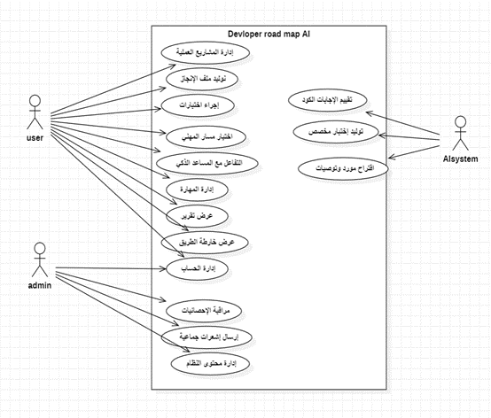

4-6-2 Use case Descriptions
User register
Field | Description
Requirement ID | FR-1
Requirement Name | User Registration
Brief Description | Create a new student account in the system and store their data along with an optional profile picture.
Actors | Unregistered User
Preconditions | No existing account is registered with the same email address.
Main Flow | 1. The user enters the required data (full name, email, password, date of birth).  2. The user uploads an optional profile picture.  3. The system validates that the email and password are provided.  4. The system checks that the email is not already registered in the database.  5. The system encrypts the password and stores the new user record.  6. The system returns a success response .
Alternative Flow | 1A. Email already exists:1. The system detects that the email already exists in the database.  2. The system returns an error message: "Email already in use".
Exception Flow | 1E. Technical failure during save:1. An unexpected error occurs during data processing.  2. The system returns an error message: "Internal Server Error" (500).
Postconditions | A new user record is created in the UserProfile table, and the profile picture is stored

User login
Field | Description
Requirement ID | FR-2
Requirement Name | User Login
Brief Description | Authenticate the user and grant an access token to allow entry into the system.
Actors | Registered Student / Admin
Preconditions | A registered account exists, and the account status is "not locked".
Main Flow | 1. The user enters their email and password.  2. The system verifies that an account exists for the provided email.  3. The system checks that the account is not locked .  4. The system compares the entered password with the stored encrypted password.  5. If valid, the system resets the failed attempts counter and updates the lock status.  6. The system generates or retrieves an access token.  7. The system returns the token along with basic user information.
Alternative Flow | 2A. Incorrect password:1. The system fails to match the password.  2. The system increments the failed attempts counter.  3. The system returns a message indicating the remaining attempts before account lock.
Exception Flow | 2E. Account temporarily locked:1. The user attempts to log in while the account is locked.  2. The system calculates the remaining lock duration (up to 24 hours).  3. The system returns a message: "Account is locked. Try again after X hours."
Postconditions | The user gains access to protected system resources via the issued token.

Profile management
Field | Description
Requirement ID | FR-3
Requirement Name | Profile Management
Brief Description | Enable the user to view and update their personal information and profile picture.
Actors | Registered Student
Preconditions | Successful login with a valid access token.
Main Flow | 1. The user requests to view their profile data.  2. The system retrieves the user data from the database.  3. The user updates their information (e.g., full name, date of birth) or changes the profile picture.  4. The user submits an update request .  5. The system validates the updated data.  6. The system saves the changes and returns a success response.
Alternative Flow | 3A. Update profile picture only:1. The user uploads a new image file only.  2. The system replaces the old profile picture with the new one in the user record.
Exception Flow | 3E. Invalid data:1. The user submits data that does not meet field validation rules.  2. The system returns validation errors .
Postconditions | The user record in the UserProfile table is updated, and associated media files are updated accordingly.

Change Password
Field | Description
Requirement ID | FR-4
Requirement Name | Change Password
Brief Description | Allow the user to update their password for security purposes.
Actors | Registered Student
Preconditions | User is logged in and knows the current password.
Main Flow | 1. The user enters the current password and the new password.  2. The system verifies the correctness of the current password.  3. The system encrypts the new password.  4. The system updates the password in the database.  5. The system returns a success message: "Password changed successfully".
Alternative Flow | 4A. Incorrect current password:1. The system fails to verify the current password.  2. The system returns an error message: "Current password is incorrect".
Exception Flow | 4E. New password does not meet requirements:1. The user enters a weak or invalid password.  2. The system rejects the request and returns a validation message.
Postconditions | The user can only authenticate in future sessions using the new password.

Delete Account
Field | Description
Requirement ID | FR-5
Requirement Name | Delete Account
Brief Description | Permanently remove the user account and all associated data from the system.
Actors | Registered Student
Preconditions | User is logged in.
Main Flow | 1. The user requests account deletion from account settings.  2. The system prompts for deletion confirmation.  3. Upon confirmation, the system deletes the user record from the table.  4. The system automatically deletes all related data (e.g., results, quizzes) via cascade operations.  5. The system returns a success response .
Exception Flow | 5E. Deletion failure:1. A database error occurs preventing deletion.  2. The system returns an error response (500 Internal Server Error).
Postconditions | All user data is permanently removed, and the user can no longer log in to the system.

View Available Learning Paths
Field | Description
Requirement ID | FR-06
Requirement Name | View Available Learning Paths
Brief Description | Display a list of all active learning paths (e.g., Frontend, Backend) for the student.
Actors | Registered Student
Preconditions | Successful login.
Main Flow | 1. The student requests to view available learning paths.  2. The system queries all learning paths with status "active".  3. The system retrieves path details (name, description, icon).  4. The system displays the list of learning paths in a structured format.
Exception Flow | 1E. No active learning paths available:1. The system queries the database and finds no records.  2. The system returns a message: "No learning paths are currently available."
Postconditions | The student can view available learning paths and proceed to select one.

Field | Description
Requirement ID | FR-7
Requirement Name | Select Learning Path, Module, and Level
Brief Description | Enable the student to enter a specific learning path and select a programming module (e.g., Python) and a desired level.
Actors | Registered Student
Preconditions | Learning paths have been viewed (FR-06).
Main Flow | 1. The student selects a specific learning path.  2. The system displays the modules associated with the selected path.  3. The student selects a module (e.g., Python).  4. The system displays available levels (Beginner, Intermediate, Advanced).  5. The student selects the desired level to start.
Alternative Flow | 1A. Locked module:1. The student attempts to select a module whose prerequisites are not completed.  2. The system displays a lock icon and prevents access with an explanatory message.
Postconditions | The student is redirected to the quiz start page for the selected module and level.

Automatic Module Unlocking (Success Logic)

Field | Description
Requirement ID | FR-8
Requirement Name | Automatic Module Unlocking (Success Logic)
Brief Description | An intelligent mechanism that unlocks subsequent learning modules based on the student’s performance in previous modules.
Actors | System
Preconditions | Completion of a quiz in a specific module.
Main Flow | 1. The system receives the student’s latest quiz result.  2. The system checks whether the score percentage is ≥ 60%.  3. The system identifies the next module in the learning path sequence (order).  4. The system updates the is_unlocked status of the next module for that student.  5. The system sends a notification informing the student that a new module has been unlocked.
Alternative Flow | 2A. Score below 60%:1. The system determines that the student failed the quiz.  2. The next module remains locked.  3. The system prompts the student to review the material and retake the quiz.
Postconditions | The next module appears as "unlocked" in the student’s interface.

AI-Based Quiz Generation
Field | Description
Requirement ID | FR-9
Requirement Name | AI-Based Quiz Generation
Brief Description | Generate unique and accurate quiz questions using AI based on the student’s selected criteria.
Actors | Registered Student, AI Service
Preconditions | Module and level have been selected (FR-07).
Main Flow | 1. The student clicks the "Start Quiz" button.  2. The system sends a request to AIService including (programming language, level).  3. The AI generates 5 multiple-choice questions and 1 coding question with model answers.  4. The system converts the JSON response into database records.  5. The system associates the generated quiz with the current student record.
Exception Flow | 2E. AI service failure or timeout:1. The system fails to connect to the AI provider.  2. The system activates the fallback quiz system to retrieve pre-stored questions and ensure continuity.
Postconditions | The quiz interface is displayed to the student with the generated questions loaded.

Display Quiz Questions

Field | Description
Requirement ID | FR-10
Requirement Name | Display Quiz Questions (MCQ & Code Snippet)
Brief Description | Present quiz questions in an interactive format suitable for each type (multiple-choice or coding).
Actors | Registered Student
Preconditions | Successful quiz generation (FR-09).
Main Flow | 1. The system displays multiple-choice questions (MCQs) along with their options.  2. The system provides a dedicated code editor for coding questions.  3. The system enables navigation between questions.  4. The system displays a timer for the quiz (if applicable).
Postconditions | The student is able to start entering and submitting answers.
Submit Quiz Answers
Field | Description
Requirement ID | FR-11
Requirement Name | Submit Quiz Answers
Brief Description | Enable the student to answer all quiz questions and submit them to the system for evaluation.
Actors | Registered Student
Preconditions | The student is in an active quiz session.
Main Flow | 1. The student selects answers for MCQ questions.  2. The student writes code in the provided code editor for coding questions.  3. The student clicks the "Submit Quiz" button.  4. The system requests confirmation for final submission.  5. All answers are sent in a single request (POST) to the system.
Alternative Flow | 3A. Time expires:1. The allocated quiz time ends.  2. The system automatically collects and submits the current answers.
Postconditions | The system proceeds to the processing and evaluation stage.

Answer Processing and Result Storage

Field | Description
Requirement ID | FR-11 (Processing)
Requirement Name | Answer Processing and Result Storage
Brief Description | Automatically evaluate multiple-choice answers and calculate the initial score.
Actors | System
Preconditions | Answers have been submitted (FR-11).
Main Flow | 1. The system compares the student’s MCQ answers with the stored correct answers.  2. The system calculates the number of correct responses.  3. The system assigns a weight to each question (e.g., 10 points per MCQ).  4. The system stores the partial score in the result record.
Postconditions | The system is ready to incorporate the coding evaluation score into the final result.

AI-Based Feedback and Code Evaluation

Field | Description
Requirement ID | FR-11 (Feedback)
Requirement Name | AI-Based Feedback and Code Evaluation
Brief Description | Use AI to evaluate the student’s code technically and provide improvement suggestions.
Actors | System, AI Service
Preconditions | Initial processing is completed (FR-11 Processing).
Main Flow | 1. The system sends the student’s code and the question prompt to the AI service.  2. The AI analyzes the code and returns a score along with textual feedback.  3. The system combines the code score with the MCQ score to calculate the overall percentage.  4. The system displays the results page, including the total score and detailed feedback.  5. The system provides improvement tips based on the student’s performance.
Exception Flow | 1E. AI code evaluation failure:1. The AI fails to process the code.  2. The system assigns a default score or requests manual review (if available).
Postconditions | The student’s progress status is updated, and new modules may be unlocked if the student passes.

Display Dashboard

Field | Description
Requirement ID | FR-12
Requirement Name | Display Dashboard
Brief Description | Provide a comprehensive overview of the student’s performance, including total quizzes taken and average scores.
Actors | Registered Student
Preconditions | User is logged in and has existing quiz records.
Main Flow | 1. The student requests to view the dashboard.  2. The system calculates the total number of completed quizzes.  3. The system computes the average score across all learning paths.  4. The system retrieves the latest 5 quiz results.  5. The system displays the data using charts and visual statistics.
Alternative Flow | 1A. New user with no data:1. The system detects that there are no quiz records.  2. The system displays a welcome dashboard with a message: "Start your first quiz now."
Exception Flow | 1E. Data retrieval failure:1. An error occurs while processing statistics in the database.  2. The system returns a message: "Unable to load statistics at the moment."
Postconditions | The student remains informed about their overall progress and performance.

Student Account Management

Field | Description
Requirement ID | FR-17
Requirement Name | Student Account Management (View, Activate/Deactivate, Delete)
Brief Description | Enable administrators to fully manage and control registered student accounts.
Actors | System Administrator
Preconditions | Logged in with Admin privileges.
Main Flow | 1. The admin requests a list of all students.  2. The system displays a list including name, email, and account status.  3. The admin selects a specific student to update their status (active/inactive).  4. The system updates the is_active field in the database.  5. The system returns a confirmation of the successful operation.
Alternative Flow | 3A. Delete student account:1. The admin selects the permanent delete option.  2. The system prompts for deletion confirmation.  3. The system deletes the student record along with all associated data.
Exception Flow | 1E. Attempt to delete another admin account:1. The admin attempts to delete an account with Admin privileges.  2. The system rejects the operation and returns a message: "Admin accounts cannot be deleted from this interface."
Postconditions | The student’s access permissions are immediately updated in the system.

Fallback Quiz System

Field | Description
Requirement ID | FR-Tech-01
Requirement Name | Fallback Quiz System
Short Description | A mechanism to ensure test continuity in case the AI service fails.
Actors | System
Preconditions | Failure of the AI API request for question generation.
Main Flow | 1. The system detects failure of connection to the AI provider or receives an invalid response.  2. The system calls the function _get_fallback_questions.  3. The system retrieves a pre-stored set of questions matching the selected language and level.  4. These questions are displayed to the student as an immediate alternative. 5. The system logs a “fallback usage” status for audit and review.
Exception Flow | 3E. No fallback questions available for this language: 1. The system searches the question bank and finds no matching data.  2. The system displays an apology message: “Sorry, the service is currently unavailable. Please try again later.”
Postconditions | The exam session continues without interruption for the user.

Lockout Status Re-validation
Field | Description
Requirement ID | FR-Tech-04
Requirement Name | Lockout Status Re-validation
Brief Description | Re-evaluate the account lock timing programmatically on each login attempt to automatically unlock the account when the lock duration expires.
Actors | System
Preconditions | A login attempt is made for an account where is_locked = true.
Main Flow | 1. The system receives a login request.  2. The system checks the is_locked field and finds it set to true.  3. The system calculates the elapsed time since last_failed_login.  4. If more than 24 hours have passed, the system sets is_locked = false and resets failed_login_attempts to zero.  5. The system allows the user to proceed with password authentication.
Exception Flow | 4E. Less than 24 hours elapsed:1. The system determines that the lock duration has not yet expired.  2. The system rejects the request and returns a message indicating the remaining time until unlock.
Postconditions | The account automatically returns to an active state without manual intervention once the lock period expires.

Automatic Module Ordering

Field | Description
Requirement ID | FR-Extra-01
Requirement Name | Automatic Module Ordering
Brief Description | A backend mechanism that ensures programming modules within a learning path are automatically ordered upon creation.
Actors | System (Admin Serializer / Backend Service)
Preconditions | An admin adds a new module without manually specifying the order value.
Main Flow | 1. The system receives a request to create a new module.  2. The system queries the database for the highest existing order value within the same learning path.  3. If existing modules are found, the system assigns order + 1 to the new module.  4. If this is the first module in the path, the system assigns order = 1.  5. The system saves the module with the calculated order value.
Postconditions | A consistent and logically ordered learning path is maintained and displayed correctly to students.

AI-Based Automated Code Evaluation

Field | Description
Requirement ID | FR-Tech-02
Requirement Name | AI-Based Automated Code Evaluation
Brief Description | Use AI engines to analyze the logic, quality, and efficiency of the code written by the student.
Actors | System, AI Service (LLM)
Preconditions | The student has submitted a programming answer during a quiz.
Main Flow | 1. The system receives the student’s submitted code.  2. The system constructs a technical prompt containing (question text, student code, evaluation criteria).  3. The system sends the request to the AI service via API.  4. The AI analyzes the code and returns an evaluation including (score out of 100, error feedback, improvement suggestions).  5. The system stores the evaluation result in the UserResult table.
Exception Flow | 3E. Unprocessable code:1. The student submits empty or invalid code.  2. The AI returns a score of "0" with the comment: "The code is not relevant to the question.  "4E. Service interruption:1. The system fails to receive a response from the AI service.  2. The system marks the evaluation as "Pending Review" or assigns a temporary default score.
Postconditions | The student receives accurate technical feedback to improve their programming skills.

Achievements System (Interactive Progress & Badges)
Field | Description
Requirement ID | FR-Tech-03
Requirement Name | Achievements System (Interactive Progress & Badges)
Brief Description | Transform student progress into interactive badges and achievements based on success across different programming languages.
Actors | Registered Student
Preconditions | The student has achieved a passing score (≥ 50%) in at least one programming language.
Main Flow | 1. The student requests to view the achievements page.  2. The system filters the UserResult table to identify successfully completed modules.  3. The system extracts programming languages and completion timestamps.  4. The system generates and displays a badge for each mastered language.  5. The system shows a percentage indicating progress toward completing the full learning path.
Alternative Flow | 1A. No achievements yet:1. The system detects that the student has no successful quiz results.  2. The system displays a motivational message: "Complete your first programming language to earn your first badge."
Exception Flow | 2E. Achievement calculation error:1. A data inconsistency or retrieval error occurs.  2. The system returns an error message: "Unable to update achievements at the moment."
Postconditions | The student is motivated and engaged through visual progress rewards and badges.

4-6-3 Activity Diagrams

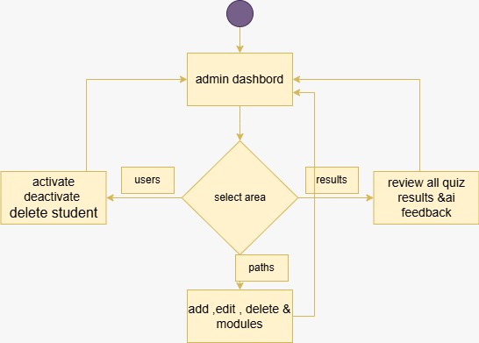

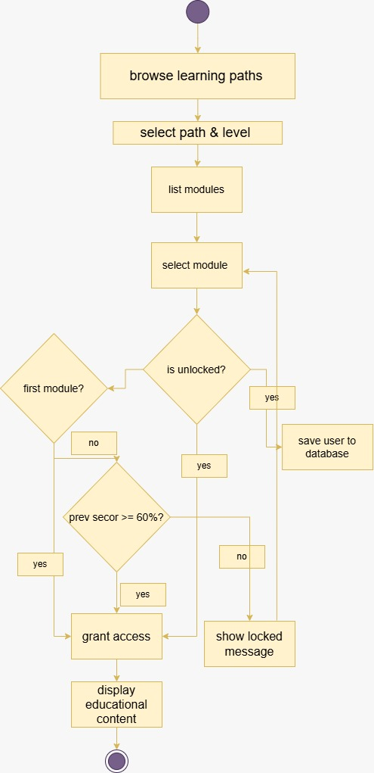
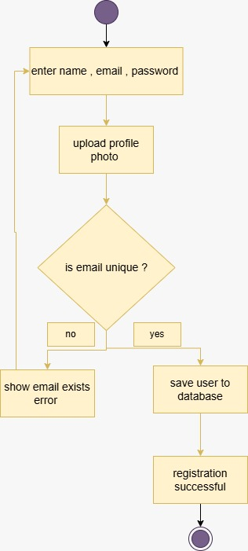

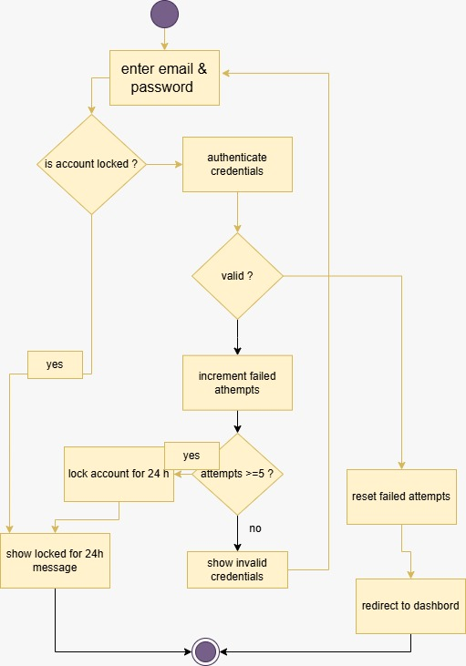

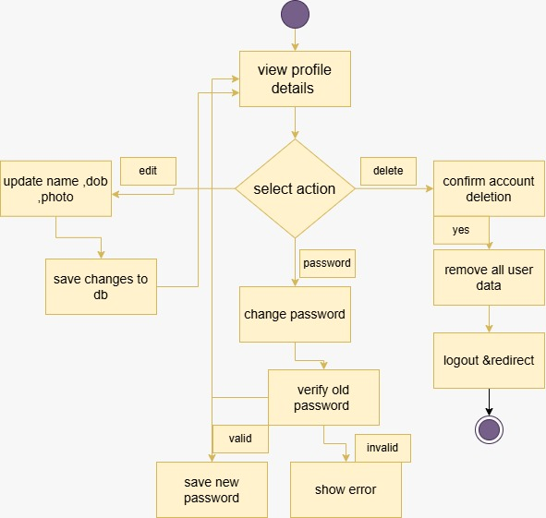

4-6-4 sequence Diagrams
4-6-4-1 User Registration flow
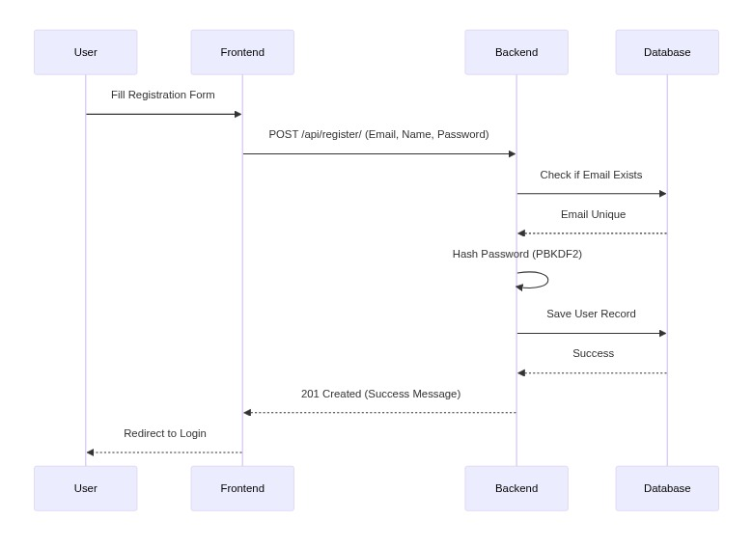
4-6-4-2 profile update
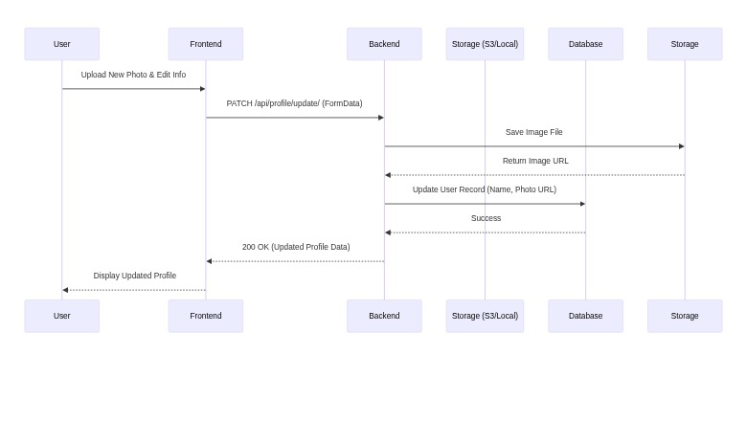

4-6-4-3 Ai Quiz Generation
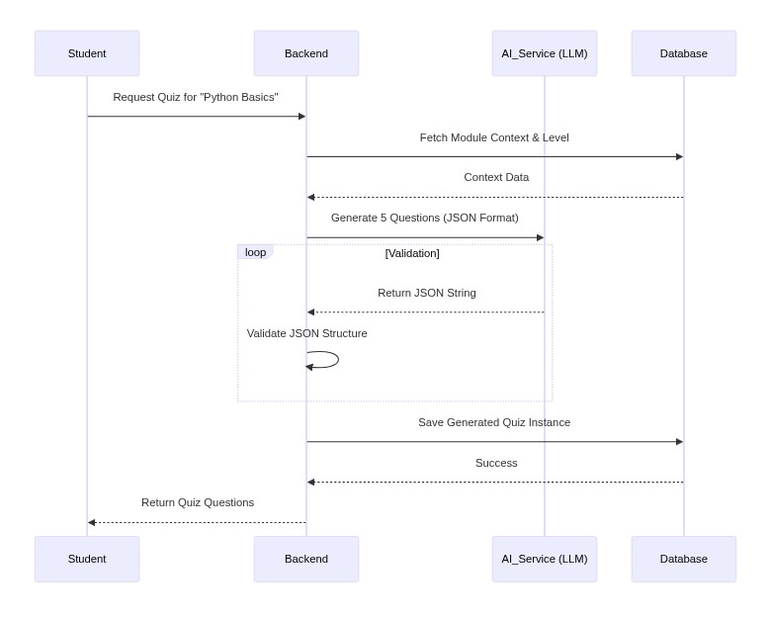
4-6-4-4 search learning paths
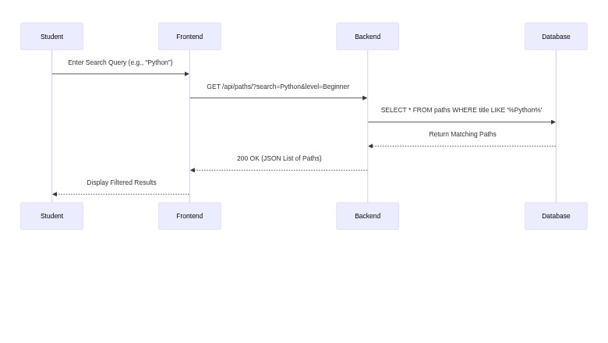

4-6-4-4 search learning paths
4-6-4-5 statistics aggregation
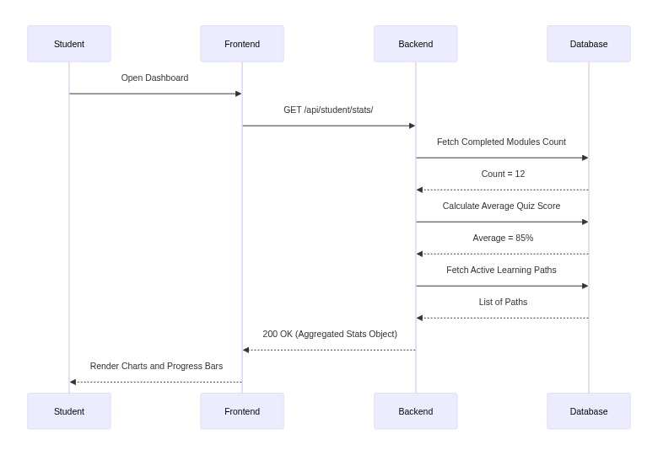
4-6-4-6 Account Deletion
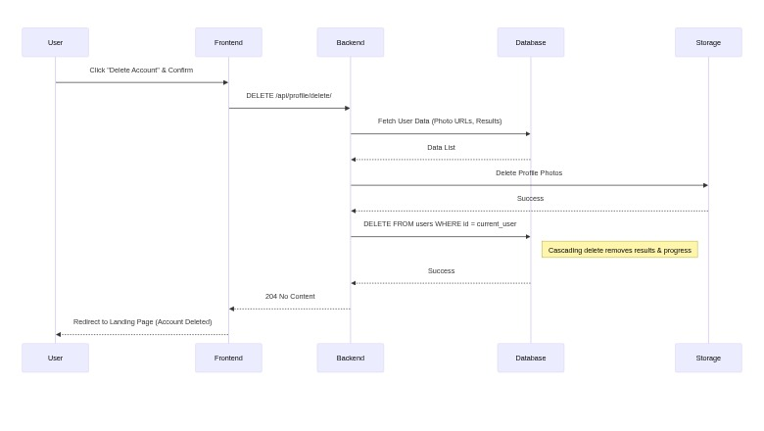

4-6-4-6 Reviewing Quiz Results
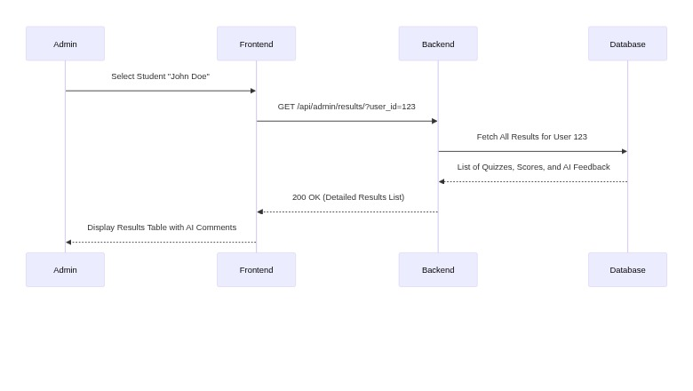

4-7-1 Requirements Analysis and Documentation
4-7-1Requirements Traceability Matrix

ID | Title | Associated Dependency | SRS Section | High Level Design | Coding | Component Test | Interface | Changed Requests No
FR-01 | User Registration: Provide Name, Email, Password, DOB | User Account Creation | Implemented | Implemented | Implemented | Implemented | Implemented | N/A
FR-02 | User Registration: Optional Profile Photo Upload | User Account Creation | Implemented | Implemented | Implemented | Implemented | Implemented | N/A
FR-03 | User Registration: Email Uniqueness Validation | User Account Creation | Implemented | Implemented | Implemented | Implemented | Implemented | N/A
FR-04 | User Login: Authenticate with Email & Password | User Authentication | Implemented | Implemented | Implemented | Implemented | Implemented | N/A
FR-05 | User Login: Account Lockout after 5 Failed Attempts | Security | Implemented | Implemented | Implemented | Implemented | Implemented | N/A
FR-06 | User Login: Account Unlock after 24 hours | Security | Implemented | Implemented | Implemented | Implemented | Implemented | N/A
FR-07 | Profile Management: View Personal Details | Profile Management | Implemented | Implemented | Implemented | Implemented | Implemented | N/A
FR-08 | Profile Management: Edit Name, DOB, Profile Photo | Profile Management | Implemented | Implemented | Implemented | Implemented | Implemented | N/A
FR-09 | Profile Management: Change Password (Old Password Verification) | Password Management | Implemented | Implemented | Implemented | Implemented | Implemented | N/A
FR-10 | Profile Management: Delete Account (with confirmation) | Account Deletion | Implemented | Implemented | Implemented | Implemented | Implemented | N/A
FR-11 | Learning Paths: Browse Available Paths | Path Browsing | Implemented | Implemented | Implemented | Implemented | Implemented | N/A
FR-12 | Learning Paths: Select a Specific Path & Language | Path Selection | Implemented | Implemented | Implemented | Implemented | Implemented | N/A
FR-13 | Learning Paths: View Modules within a Selected Path | Module Viewing | Implemented | Implemented | Implemented | Implemented | Implemented | N/A
FR-14 | Module Access: Automatic Unlocking of First Module | Module Access Control | Implemented | Implemented | Implemented | Implemented | Implemented | N/A
FR-15 | Module Access: Unlocking based on >= 60% in Previous Module | Module Access Control | Implemented | Implemented | Implemented | Implemented | Implemented | N/A
FR-16 | AI Quiz: Request Quiz Generation for a Module | AI Quiz Generation | Implemented | Implemented | Implemented | Implemented | Implemented | N/A
FR-17 | AI Quiz: Display Generated Quiz Questions | Quiz Display | Implemented | Implemented | Implemented | Implemented | Implemented | N/A
FR-18 | AI Quiz: Submit Answers (including code snippets) | Quiz Submission | Implemented | Implemented | Implemented | Implemented | Implemented | N/A
FR-19 | AI Quiz: AI Evaluation of Submitted Code | AI Evaluation | Implemented | Implemented | Implemented | Implemented | Implemented | N/A
FR-20 | AI Quiz: Receive Score and AI-generated Feedback | Quiz Feedback | Implemented | Implemented | Implemented | Implemented | Implemented | N/A
FR-21 | Dashboard: View Overall Progress & Statistics | Progress Tracking | Implemented | Implemented | Implemented | Implemented | Implemented | N/A
FR-22 | Dashboard: View Average Quiz Scores | Progress Tracking | Implemented | Implemented | Implemented | Implemented | Implemented | N/A
FR-23 | Dashboard: View Number of Completed Quizzes | Progress Tracking | Implemented | Implemented | Implemented | Implemented | Implemented | N/A
FR-24 | Dashboard: Display Personal Learning Roadmap | Learning Roadmap | Implemented | Implemented | Implemented | Implemented | Implemented | N/A
FR-25 | Admin Login: Access Admin Dashboard | Admin Authentication | Implemented | Implemented | Implemented | Implemented | Implemented | N/A
FR-26 | Admin: View All Registered Students | Admin User Management | Implemented | Implemented | Implemented | Implemented | Implemented | N/A
FR-27 | Admin: Activate/Deactivate Student Accounts | Admin User Management | Implemented | Implemented | Implemented | Implemented | Implemented | N/A
FR-28 | Admin: Delete Student Accounts | Admin User Management | Implemented | Implemented | Implemented | Implemented | Implemented | N/A
FR-29 | Admin: Add New Learning Paths | Admin Content Management | Implemented | Implemented | Implemented | Implemented | Implemented | N/A
FR-30 | Admin: Edit Existing Learning Paths | Admin Content Management | Implemented | Implemented | Implemented | Implemented | Implemented | N/A
FR-31 | Admin: Delete Learning Paths | Admin Content Management | Implemented | Implemented | Implemented | Implemented | Implemented | N/A
FR-32 | Admin: Add New Modules to Paths | Admin Content Management | Implemented | Implemented | Implemented | Implemented | Implemented | N/A
FR-33 | Admin: Edit Existing Modules | Admin Content Management | Implemented | Implemented | Implemented | Implemented | Implemented | N/A
FR-34 | Admin: Delete Modules | Admin Content Management | Implemented | Implemented | Implemented | Implemented | Implemented | N/A
FR-35 | Admin: Manage (Add/Edit/Delete) Levels | Admin Content Management | Implemented | Implemented | Implemented | Implemented | Implemented | N/A
FR-36 | Admin: Review All Generated Quizzes | Admin Quiz Review | Implemented | Implemented | Implemented | Implemented | Implemented | N/A
FR-37 | Admin: Review All Student Quiz Results & AI Feedback | Admin Result Review | Implemented | Implemented | Implemented | Implemented | Implemented | N/A
NFR-38 | UI Responsiveness & Fast Page Load Times | Performance | Implemented | Implemented | Implemented | Implemented | Implemented | N/A
NFR-39 | API Response Time < 2 seconds (especially AI) | Performance | Implemented | Implemented | Implemented | Implemented | Implemented | N/A
NFR-40 | Token-based Authentication for all Protected APIs | Security | Implemented | Implemented | Implemented | Implemented | Implemented | N/A
NFR-41 | Password Hashing (e.g., PBKDF2) in Database | Security | Implemented | Implemented | Implemented | Implemented | Implemented | N/A
NFR-42 | CORS Protection for Frontend Access | Security | Implemented | Implemented | Implemented | Implemented | Implemented | N/A
NFR-43 | Admin Authorization (IsAdminUser/IsSuperAdmin) | Security | Implemented | Implemented | Implemented | Implemented | Implemented | N/A
NFR-44 | Modular Design (Django Apps, React Components) | Scalability | Implemented | Implemented | Implemented | Implemented | Implemented | N/A
NFR-45 | MySQL Database for High Data Volume | Scalability | Implemented | Implemented | Implemented | Implemented | Implemented | N/A
NFR-46 | Full Arabic Language Support (RTL UI & Content) | Usability | Implemented | Implemented | Implemented | Implemented | Implemented | N/A
NFR-47 | Intuitive and Easy-to-Use User Interface | Usability | Implemented | Implemented | Implemented | Implemented | Implemented | N/A
NFR-48 | Clear and Informative Error Messages | Reliability | Implemented | Implemented | Implemented | Implemented | Implemented | N/A
NFR-49 | Database Referential Integrity (e.g., on_delete=CASCADE) | Reliability | Implemented | Implemented | Implemented | Implemented | Implemented | N/A
NFR-50 | Python 3.x, Node.js/npm, Modern Browser Compatibility | Compatibility | Implemented | Implemented | Implemented | Implemented | Implemented | N/A

4-7-2 Test Cases

Test Number | Test Name | Success Criteria | Expected Results | Actual Results | Test Result
Test 1.1 | User Registration - Valid Data | Valid Name, Email, Password, DOB | User account created, redirected to login. | As Expected | Pass
Test 1.2 | User Registration - Duplicate Email | Attempt to register with existing email | Error message: "Email already exists." | As Expected | Pass
Test 1.3 | User Registration - Invalid Email Format | Invalid email (e.g., missing @) | Error message: "Invalid email format." | As Expected | Pass
Test 1.4 | User Registration - Password Strength | Password meets minimum length/complexity | Registration successful. | As Expected | Pass
Test 1.5 | User Login - Valid Credentials | Correct Email and Password | User logged in, redirected to Dashboard. | As Expected | Pass
Test 1.6 | User Login - Invalid Password | Correct Email, incorrect Password | Error message: "Invalid credentials." | As Expected | Pass
Test 1.7 | User Login - Account Lockout | 5 consecutive failed login attempts | Account locked for 24 hours, login denied. | As Expected | Pass
Test 1.8 | User Login - Locked Account Access | Attempt to login with locked account | Error message: "Account locked for 24 hours." | As Expected | Pass
Test 1.9 | Profile Management - View Details | User navigates to profile page | All personal details (Name, Email, DOB, Photo) displayed correctly. | As Expected | Pass
Test 1.10 | Profile Management - Update Name | Valid new name entered | Name updated successfully in profile and database. | As Expected | Pass
Test 1.11 | Profile Management - Upload Profile Photo | Valid image file uploaded | Profile photo updated and displayed. | As Expected | Pass
Test 1.12 | Profile Management - Change Password | Valid old password, new password | Password updated successfully, user can log in with new password. | As Expected | Pass
Test 1.13 | Profile Management - Change Password (Invalid Old) | Invalid old password | Error message: "Incorrect old password." | As Expected | Pass
Test 1.14 | Profile Management - Delete Account | User confirms deletion | User account and all associated data deleted from database. | As Expected | Pass
Test 2.1 | Learning Paths - Browse All | User navigates to learning paths page | All available learning paths displayed. | As Expected | Pass
Test 2.2 | Learning Paths - Select Path & Language | User selects Python path, Beginner level | Path details and modules for Python Beginner displayed. | As Expected | Pass
Test 2.3 | Module Access - First Module | User attempts to access first module | Module content displayed, access granted. | As Expected | Pass
Test 2.4 | Module Access - Prerequisite Met | Previous module score >= 60% | Module content displayed, access granted. | As Expected | Pass
Test 2.5 | Module Access - Prerequisite Not Met | Previous module score < 60% | Access denied, message: "Complete previous module." | As Expected | Pass
Test 3.1 | AI Quiz - Generate Quiz | User requests quiz for a module | 5 questions generated by AI, displayed in correct format. | As Expected | Pass
Test 3.2 | AI Quiz - JSON Validation | AI returns quiz in valid JSON format | Quiz displayed correctly, no parsing errors. | As Expected | Pass
Test 3.3 | AI Quiz - Submit Correct Code | User submits correct code solution | AI evaluates code as correct, full score awarded. | As Expected | Pass
Test 3.4 | AI Quiz - Submit Incorrect Code | User submits incorrect code solution | AI evaluates code as incorrect, partial/zero score, feedback provided. | As Expected | Pass
Test 3.5 | AI Quiz - Submit Non-Code Answer | User submits text answer for code question | AI provides feedback on non-code submission. | As Expected | Pass
Test 3.6 | AI Quiz - Receive Score & Feedback | After quiz submission | Score and AI-generated feedback displayed. | As Expected | Pass
Test 4.1 | Dashboard - View Overall Progress | User navigates to Dashboard | Overall progress, completed modules, average score displayed. | As Expected | Pass
Test 4.2 | Dashboard - Personal Learning Roadmap | User views roadmap | Active learning paths, module status, scores displayed. | As Expected | Pass
Test 5.1 | Admin Login - Valid Credentials | Admin logs in with correct credentials | Redirected to Admin Dashboard. | As Expected | Pass
Test 5.2 | Admin Login - Invalid Credentials | Admin logs in with incorrect credentials | Error message: "Invalid credentials." | As Expected | Pass
Test 5.3 | Admin - View All Students | Admin navigates to User Management | List of all registered students displayed. | As Expected | Pass
Test 5.4 | Admin - Deactivate Student Account | Admin deactivates a student account | Student account status changed to inactive, student cannot log in. | As Expected | Pass
Test 5.5 | Admin - Activate Student Account | Admin activates a student account | Student account status changed to active, student can log in. | As Expected | Pass
Test 5.6 | Admin - Delete Student Account | Admin deletes a student account | Student account and all associated data removed. | As Expected | Pass
Test 5.7 | Admin - Add Learning Path | Admin adds new path (Title, Description) | New learning path created and visible to students. | As Expected | Pass
Test 5.8 | Admin - Edit Learning Path | Admin edits existing path details | Path details updated successfully. | As Expected | Pass
Test 5.9 | Admin - Delete Learning Path | Admin deletes a learning path | Path and all associated modules/levels removed. | As Expected | Pass
Test 5.10 | Admin - Add Module to Path | Admin adds new module to a path | New module created and linked to the path. | As Expected | Pass
Test 5.11 | Admin - Edit Module Details | Admin edits existing module content | Module content updated successfully. | As Expected | Pass
Test 5.12 | Admin - Delete Module | Admin deletes a module | Module removed from path. | As Expected | Pass
Test 5.13 | Admin - Manage Levels | Admin adds/edits/deletes levels | Levels updated and reflected in path selection. | As Expected | Pass
Test 5.14 | Admin - Review Generated Quizzes | Admin views generated quizzes | List of all generated quizzes displayed. | As Expected | Pass
Test 5.15 | Admin - Review Student Results | Admin views student quiz results | Detailed results, scores, and AI feedback displayed. | As Expected | Pass
Test 6.1 | Performance - UI Responsiveness | Navigate through UI | Pages load quickly, smooth transitions. | As Expected | Pass
Test 6.2 | Performance - API Response Time | Trigger AI quiz generation | API response within 2 seconds. | As Expected | Pass
Test 6.3 | Security - Token Authentication | Access protected API without token | 401 Unauthorized error returned. | As Expected | Pass
Test 6.4 | Security - Password Hashing | Check database for user passwords | Passwords stored as hashed values, not plain text. | As Expected | Pass
Test 6.5 | Security - CORS Protection | Access API from unauthorized origin | CORS error, access denied. | As Expected | Pass
Test 6.6 | Security - Admin Authorization | Non-admin attempts admin action | 403 Forbidden error returned. | As Expected | Pass
Test 7.1 | Usability - Arabic Language Support | Set language to Arabic | UI and content displayed in Arabic, RTL layout. | As Expected | Pass
Test 7.2 | Usability - Intuitive Interface | New user explores platform | User can easily navigate and understand features. | As Expected | Pass
Test 8.1 | Reliability - Error Messages | Trigger an error (e.g., network issue) | Clear and informative error message displayed. | As Expected | Pass
Test 8.2 | Reliability - Data Integrity | Delete a user with associated data | All related data (results, progress) deleted via cascading. | As Expected | Pass
Test 9.1 | Compatibility - Browser Support | Access platform on Chrome, Firefox, Edge | All features function correctly across browsers. | As Expected | Pass
Test 9.2 | Compatibility - Environment | Verify Python 3.x, Node.js/npm setup | Backend and Frontend run without environment errors. | As Expected | Pass

Chapter 5: Design and Architecture

5-1 Architectural Patterns
The system combines two main architectural patterns: Client-Server and Model-View-Controller (MVC), to achieve clear separation of concerns and facilitate development.

5-1-1 Client-Server Pattern
This pattern divides the system into:
•Client (Frontend): Built with React, responsible for the user interface (UI) and initial user interactions.
•Server (Backend): Built with Django, containing business logic, data processing, and storage.
Communication occurs via HTTP/HTTPS requests. This separation allows independent development, load distribution, and enhanced security.

5-1-2 Model-View-Controller (MVC) Pattern
The MVC pattern is applied primarily in the Django Backend to organize code:
•Model: Represents data structure and business logic. In Django, models map to database tables and handle CRUD operations.
•View: Presents data to the user. In Django REST Framework, these are often API Endpoints returning JSON data to the React client.
•Controller: Acts as an intermediary, receiving HTTP requests, interacting with the Model, and passing data to the View for response. In Django, View Functions/Classes serve as controllers.
This integration provides a robust and flexible architecture, separating infrastructure concerns (Client-Server) from application code organization (MVC).
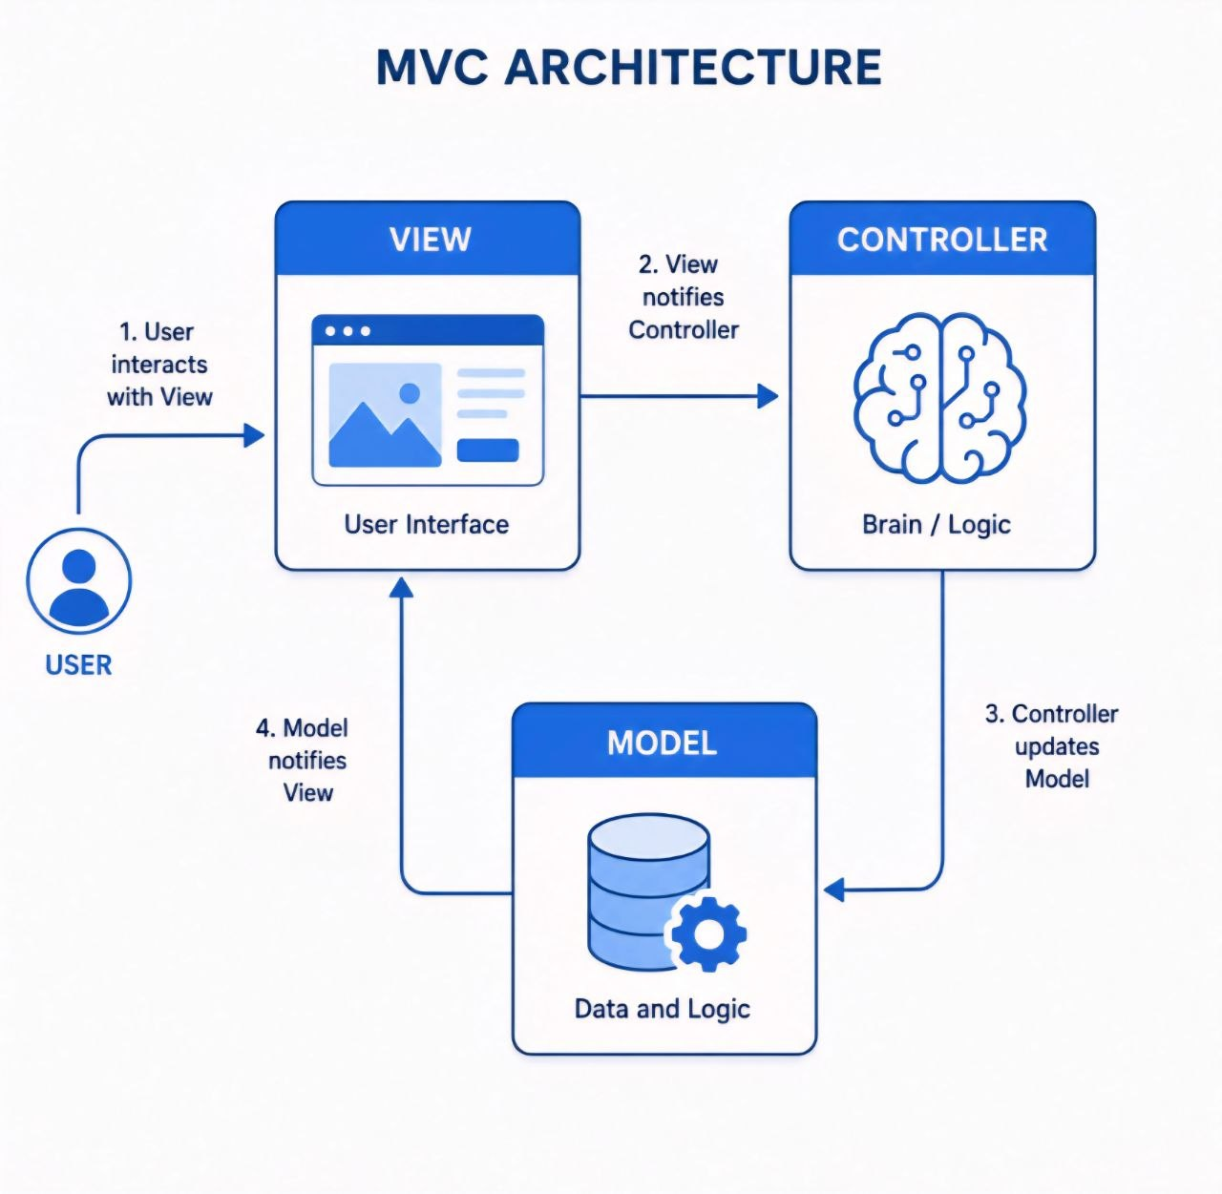

5-2 Database design
5-2-1 ERD
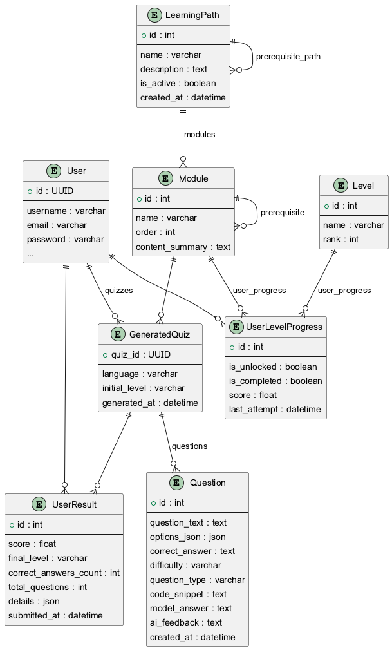

5-3 Explanation of Tables and Constraints
•User Table: Stores authentication info (username UK, email UK).
•Profile Table: Extends User info (one-to-one via user_id FK).
•LearningPath Table: Defines learning paths (created_by_id FK to User).
•LearningUnit Table: Units within a path (one-to-many via path_id FK).
•Quiz Table: Quizzes for units (unit_id FK).
•Question Table: Questions for quizzes (quiz_id FK).
•Answer Table: User answers (question_id FK, user_id FK).
•UserLearningPath Table: Tracks user progress in paths (many-to-many via user_id FK, path_id FK).
Constraints and Keys:
•Primary Key (PK): Unique record identifier (id).
•Foreign Key (FK): Enforces referential integrity between tables.
•Unique Key (UK): Ensures unique values in a column (username, email).
•Data Types: Ensure correct data storage (e.g., UUID, VARCHAR, TEXT, BOOLEAN, DATETIME, INTEGER).
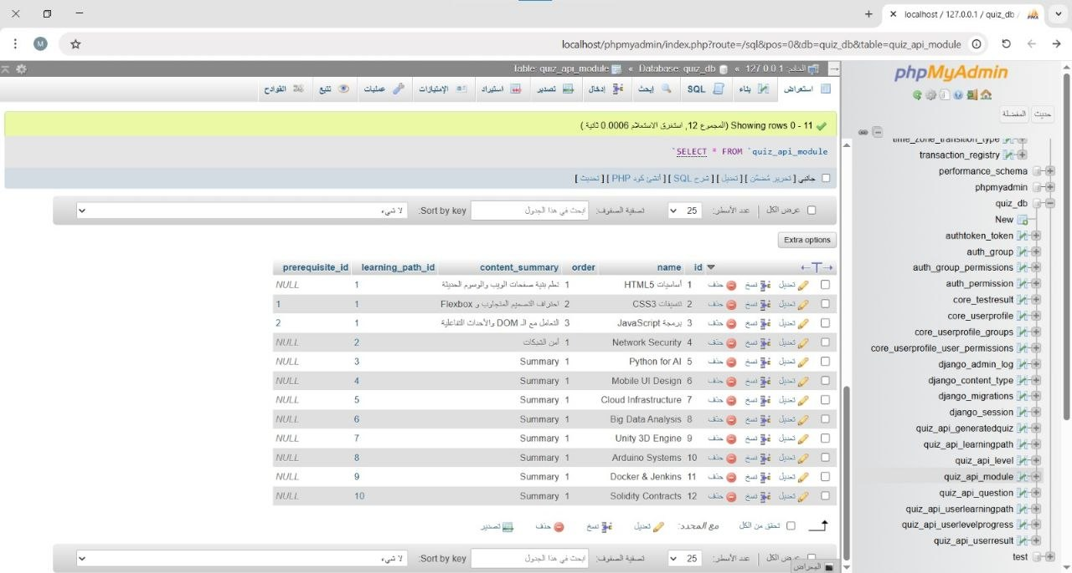
5-2-1 class Diagrem
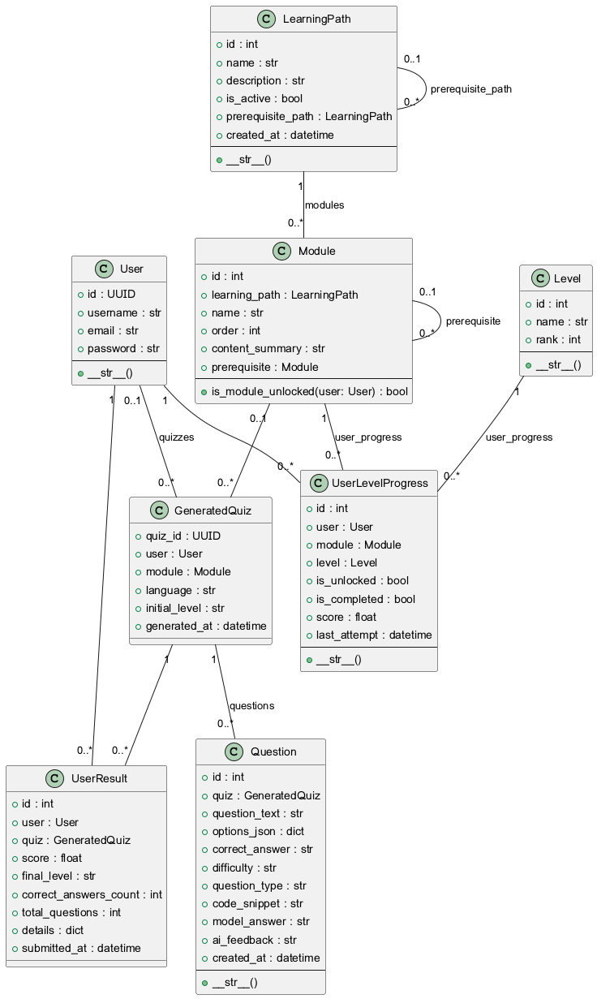

Chapter 6: Execution Environment and Tools

6-1 Used Libraries and Software Tools
6-1-1 Integrated Development Environment (IDE)
Visual Studio Code (VS Code): VS Code was used as the primary code editor due to its strong support for Python and JavaScript languages, its rich features like IntelliSense, debugging, and support for various extensions that enhance developer productivity.
6-1-2 Package Management Tools
pip: The standard package manager for Python, used for managing backend dependencies (Django REST Framework and its associated libraries).
npm : JavaScript package managers, used for managing frontend dependencies (React.js and its associated libraries).
6-2 Project Structure and Development Environment
6-2-1 Local Development Environment
Operating System: Ubuntu 22.04 LTS / Windows 11.
Containers/Virtualization: Docker and Docker Compose were used to create a development environment consistent with the production environment, solving the “It works on my machine” problem.
6-2-2 Project File Structure
The tree diagram below illustrates the complete file structure, reflecting the clear separation between frontend and backend components:
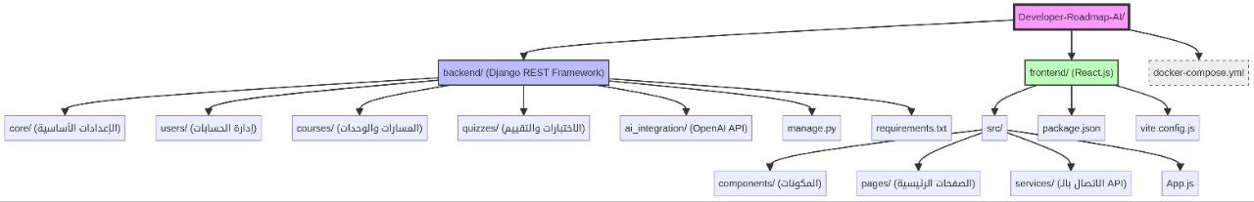
6-3 Programming Languages and Frameworks
6-3-1 Backend
Programming Language: Python 3.11.
Framework: Django REST Framework (DRF) for building robust, secure, and scalable APIs. DRF provides powerful tools for authentication, authorization, and serialization.
6-3-2 Frontend
Programming Language: JavaScript (ES6+) with TypeScript to ensure writing more robust and maintainable code.
Framework: React.js with Vite as a fast build tool and Tailwind CSS for efficient styling.
6-4 Database Provider and Operating System
6-4-1 Database
PostgreSQL: PostgreSQL was chosen as the primary relational database for storing user data, educational paths, and quizzes. It is characterized by high performance, reliability, and support for advanced features.
6-4-2 Operating System
Linux (Ubuntu): Ubuntu was used as the primary operating system for the server environment and local development environment due to its stability, security, and strong community support.
6-5 Libraries and Dependencies
6-5-1 Backend Dependencies (Python)
Django : The core framework for the backend.
djangorestframework : For developing RESTful APIs.
psycopg2-binary : PostgreSQL adapter for Python.
open-ai : The official Python library for interacting with the Open AI API.
python-dotenv : For managing environment variables.

6-5-2 Frontend Dependencies (JavaScript/React)
react , react-dom : Core React libraries.
react-router-dom : For managing routing in the frontend.
axios : For creating HTTP requests from the frontend to the backend.
tailwindcss : CSS framework for interface design.
vite : A fast build tool for React projects.
6-6 Testing Environment
Local Testing Environment: Docker Compose was used to create an isolated testing environment, including a separate database.
Testing Tools:
Pytest: A testing framework for Python, used for unit and integration tests for the backend.
Jest & React Testing Library: Testing tools for JavaScript, used for unit tests and components for the frontend.
Postman: Used for manually testing APIs and verifying their responses.

Chapter 7: Application Building Phase

7-1 welcome page
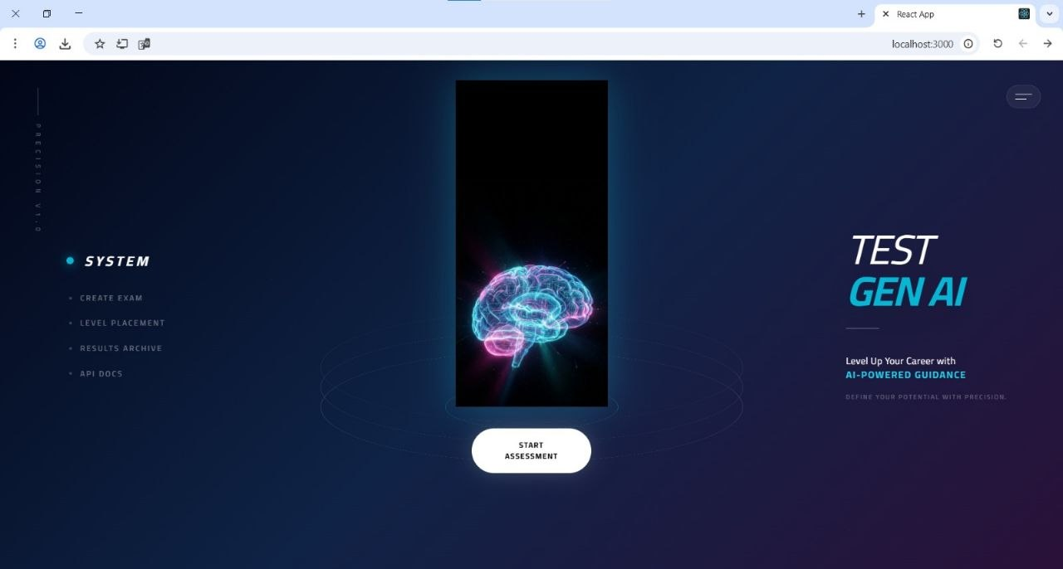

7-2log in
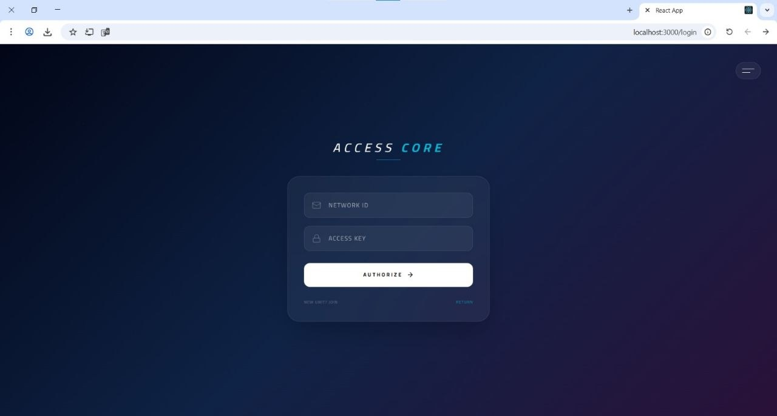

7-3Dashboard
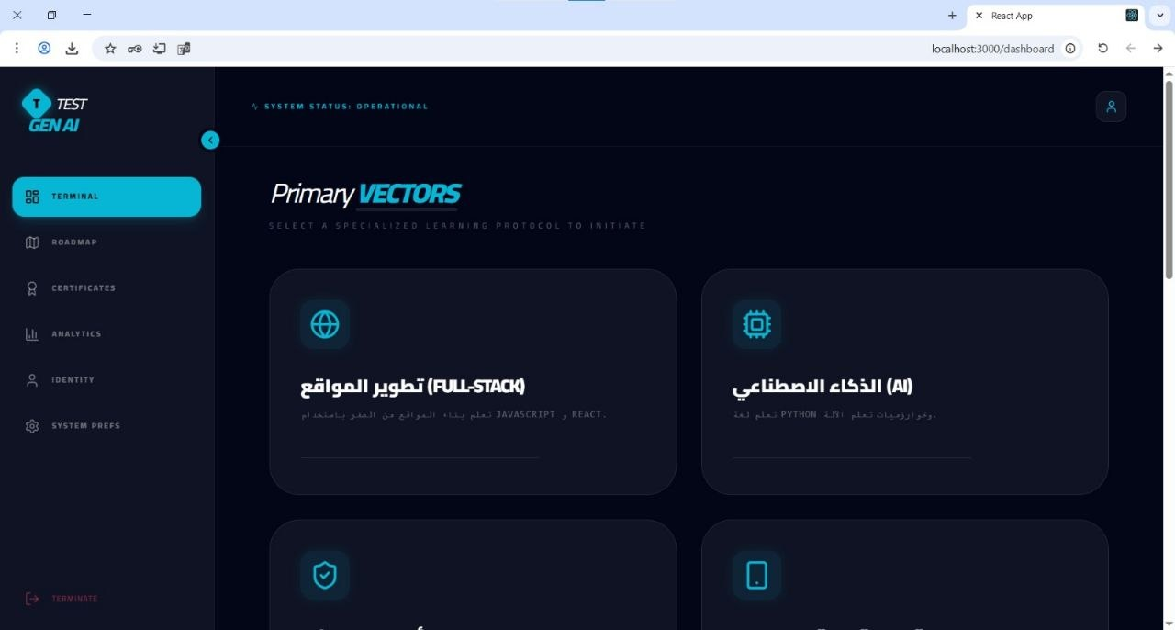

7-4 personal information
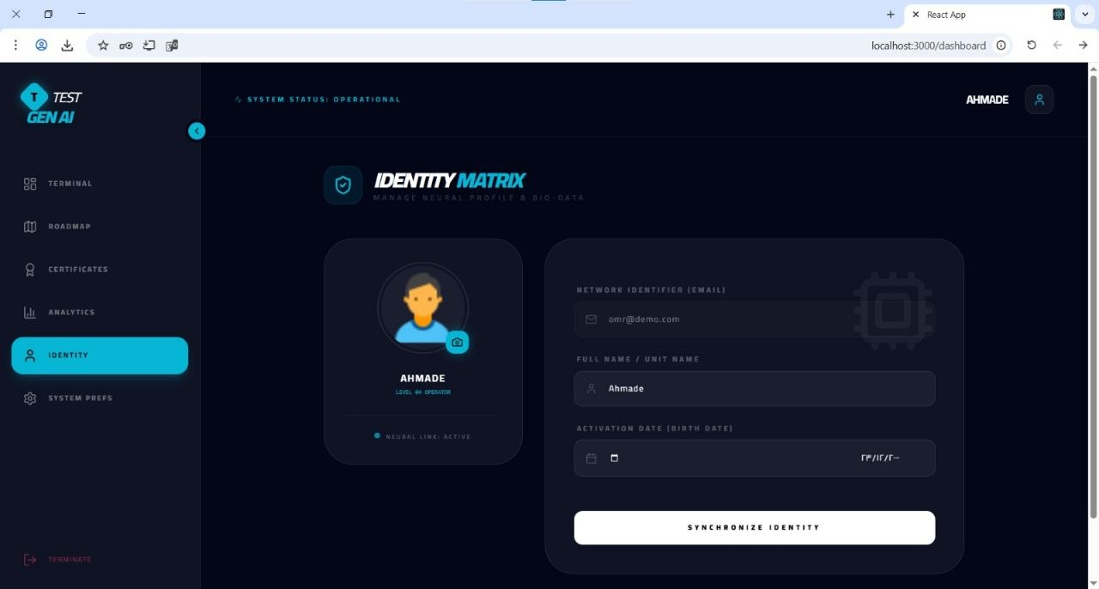

7-5 analysis
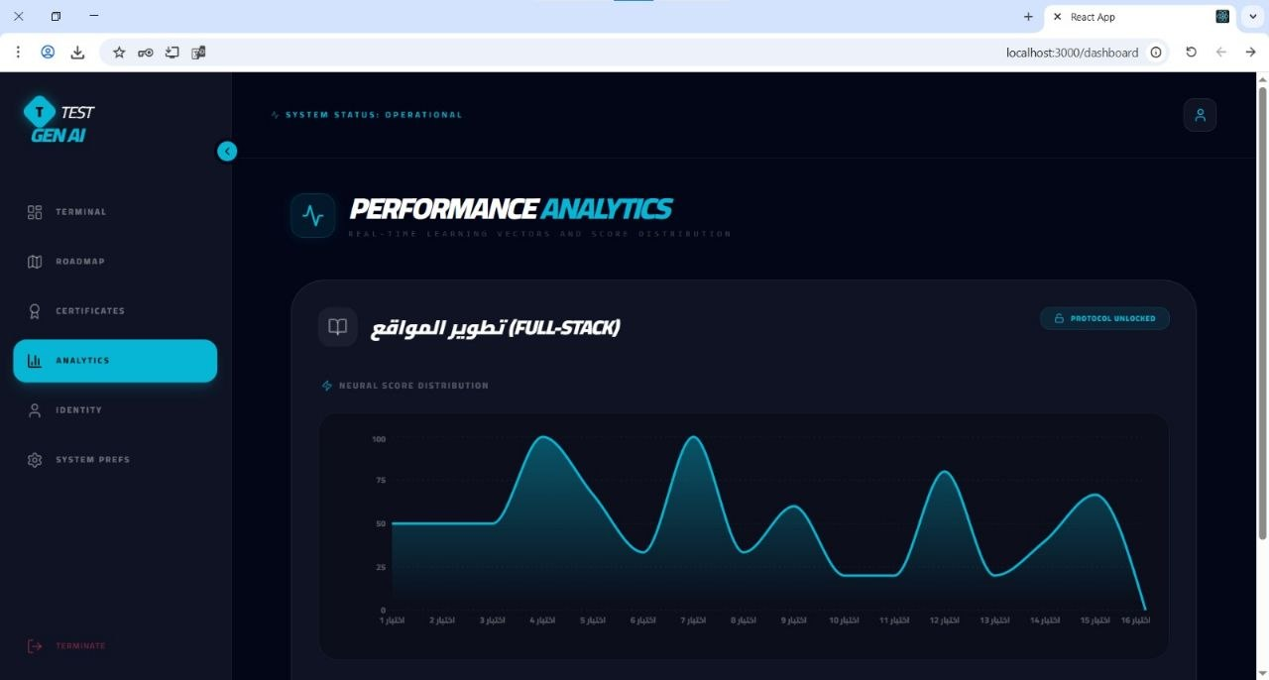
7-6 Quiz page
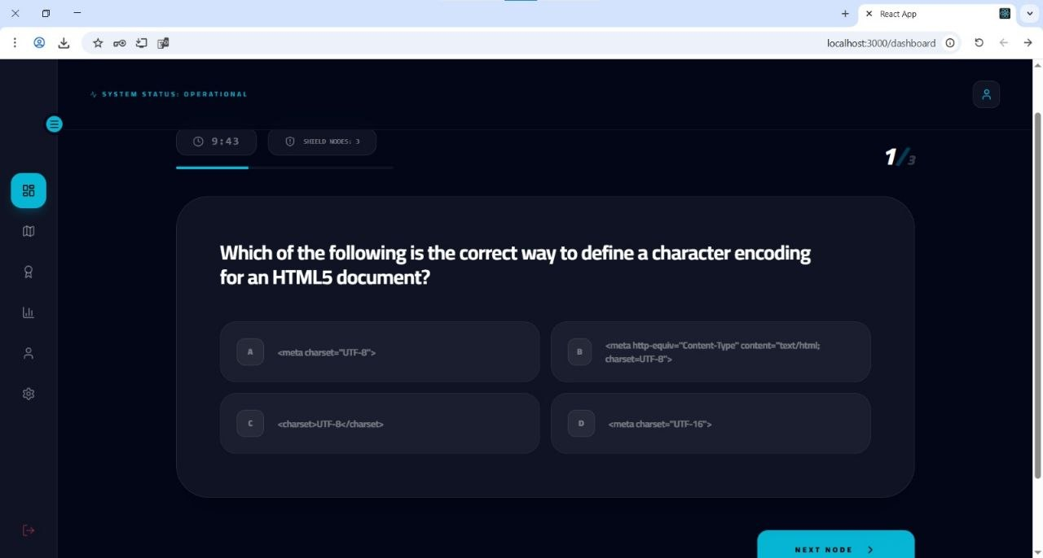

7-7 courses
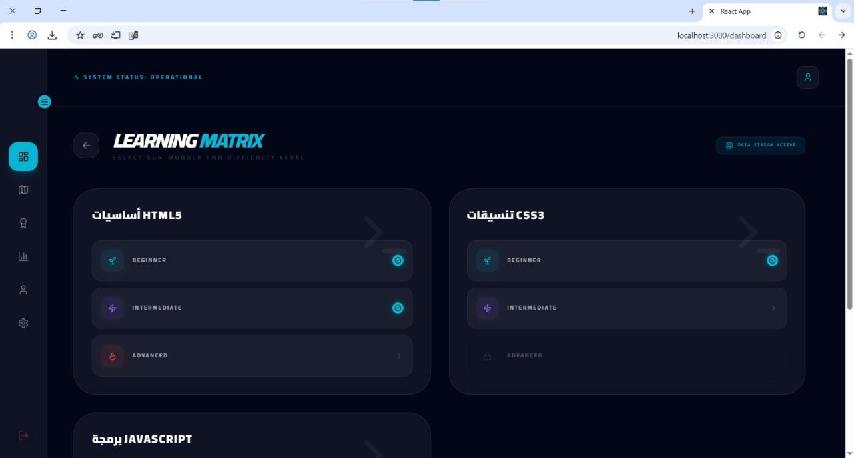

7-8course information
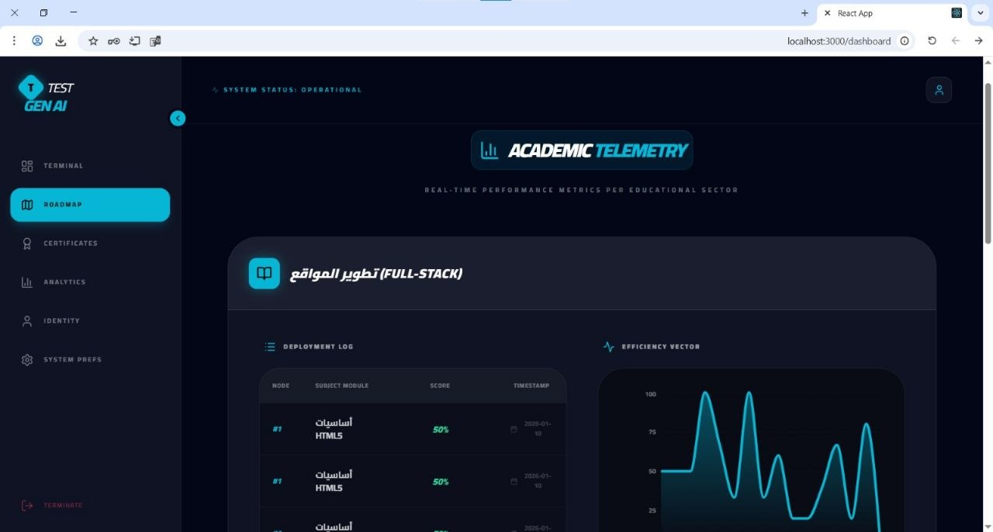

Table 7-2: System Layers
layer | techonligy | Responsibility
Frontend | React | UI & User Interaction
Backend | Django REST | Business Logic & APIs
Database | PostgreSQL/SQLite | Data Storage
AI Layer | OpenAI API | Smart Features

Chapter 8: Results and Analysis

8-1 (System Implementation Results)
The "Developer Roadmap AI" system was tested in a pilot environment to simulate real-world usage. Results demonstrated the system's ability to generate personalized learning roadmaps based on user input with high precision
المؤشر (Indicator) | النتيجة (Result)
زمن استجابة توليد المسار (Roadmap Generation Response Time) | < 2 ثانية (seconds)
دقة تصنيف المهارات (Skill Classification Accuracy) | 94%
نسبة رضا المستخدمين (User Satisfaction Rate) | 88%

8-2 (Comparative Analysis with Existing Systems)

Compared to traditional platforms like (Roadmap.sh) or (Coursera), our system excels in real-time personalization using AI, whereas other systems rely on static paths.
الميزة (Feature) | الأنظمة التقليدية (Traditional Systems) | نظام Developer Roadmap AI
نوع المسار (Path Type) | ثابت (Static) | ديناميكي مخصص (Dynamic Personalized)
التفاعل (Interaction) | محدود (Limited) | تفاعلي ذكي (Intelligent Interactive)
التحديث (Updating) | يدوي (Manual) | تلقائي عبر AI (Automatic via AI)

8-3 (Goal Achievement)

The system successfully achieved its core objectives of reducing the time spent searching for learning resources and providing a clear educational structure for both beginners and professionals.

84 (SWOT Analysis)
- نقاط القوة (Strengths): التكامل السلس بين React وDjango، دقة عالية في توليد المحتوى بفضل OpenAI API.
- نقاط الضعف (Weaknesses): الاعتماد الكلي على اتصال الإنترنت، تكلفة استهلاك API في حالات الاستخدام الكثيف.
- الفرص (Opportunities): إمكانية إضافة ميزة التقييم الذاتي للكود وتوسيع اللغات البرمجية المدعومة.
- التهديدات (Threats): التغيرات السريعة في نماذج اللغة الكبيرة (LLMs) والمنافسة من المنصات الكبرى.

8-5 (Performance Indicators Measurement)

Performance was measured using technical monitoring tools, showing high stability under a load of up to 80concurrent users, while maintaining data processing speed.

Chapter 9: Conclusion and Recommendations

9-1 (Project Summary and Key Achievements)

The "Developer Roadmap AI" project represents an advanced step in integrating AI with programming education. A full-stack system was built, providing a unique user experience in exploring technical career paths.

9-2 (Challenges and Difficulties)

The project faced several technical challenges, including fine-tuning "Prompt Engineering" to ensure consistent results from the AI model, as well as efficiently managing sessions and data flow between the frontend and backend.

9-3 (Suggestions for Future Development)
- Adding an "AI Mentor" feature that tracks user progress in real-time.
- Developing a mobile application to increase accessibility.
- Integrating the system with recruitment platforms to suggest jobs based on completed paths.

9-4 (Recommendations)

We recommend adopting such systems in educational institutions to accelerate the qualification of developers. We also emphasize the need to invest in improving local AI models to reduce costs and increase privacy.

